**COMP250 Key Terms**

1. **A directed edge is:** an ordered pair of nodes(v1,v2)(from,to)
2. **A child is**: a node directly connected to another node when moving away from the root
3. **A parent is**: a node directly connected to another node when moving towards the root
4. **Siblings have:** same parent
5. **An internal node is:** a node with at least one child
6. **A leaf(or external node) is:** a node with no children
7. **The length of a path is:** the number of edges in the path
8. **Opposite of ancestor going from v(ancestor) to w:** descendent
9. **The depth (or level) of a node is:** the length of the path from the root to the node
10. **The height of a node is:** the maximum length of a path from that node to a leaf
11. Traverse tree preorder:

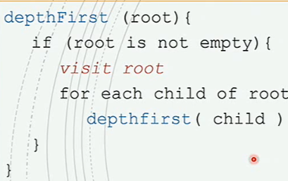

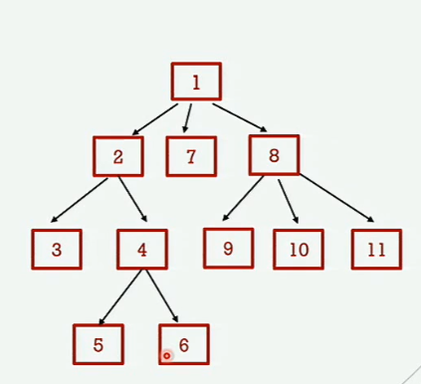

1. Traverse tree postorder:

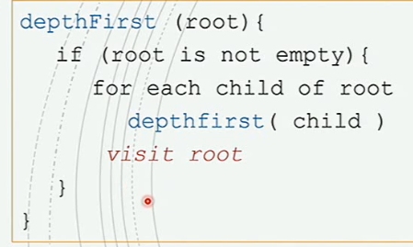

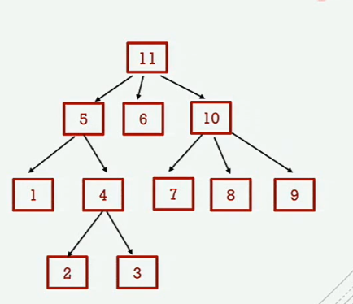

1. Tree traversal with stack

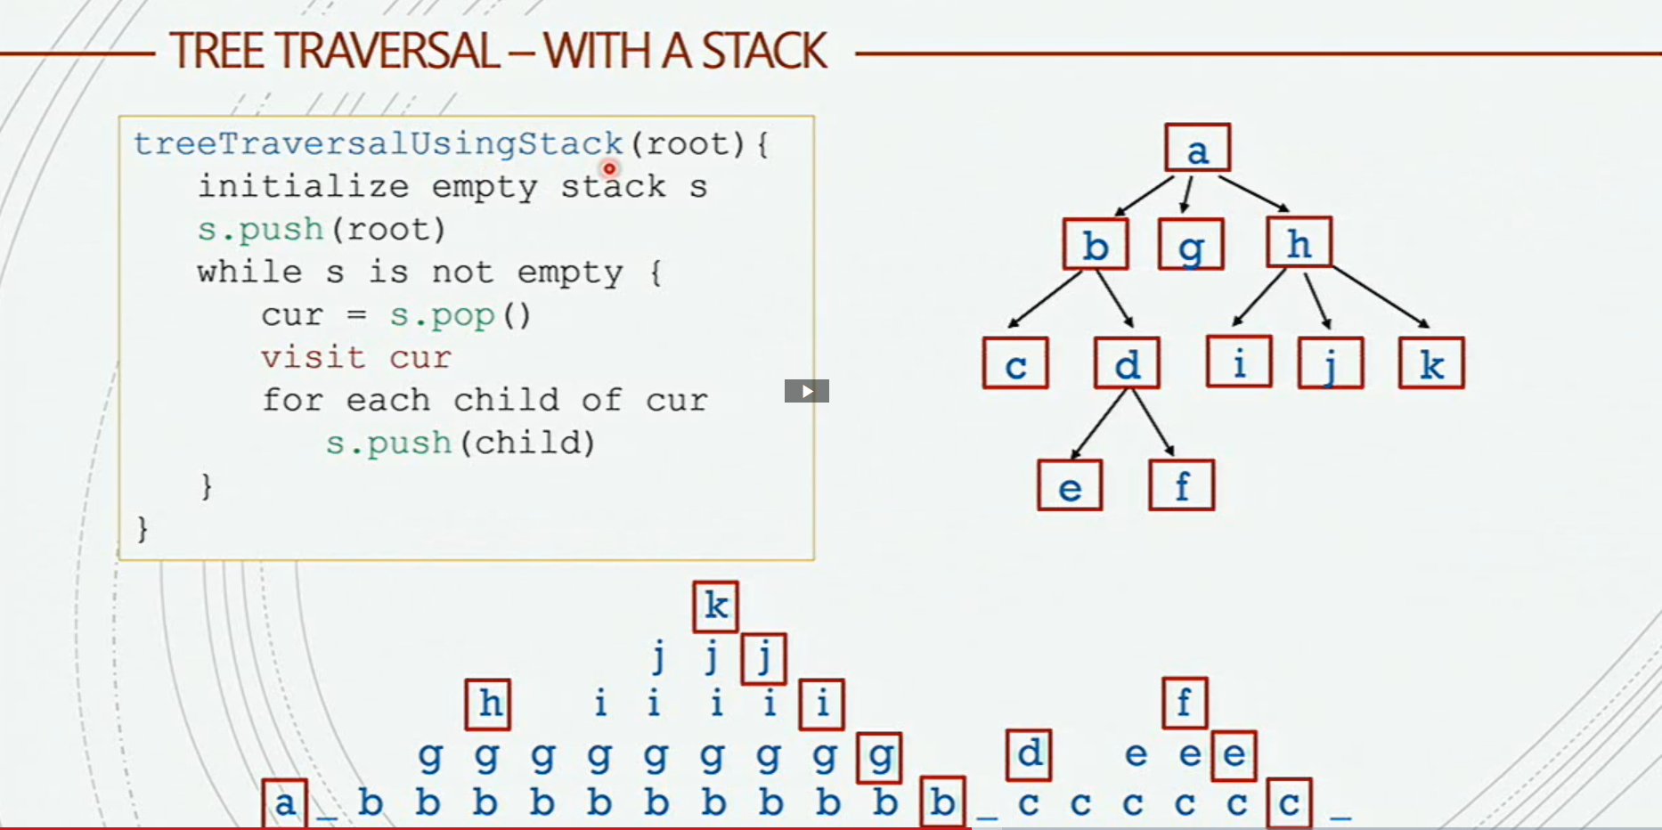

1. Breadth-first example: 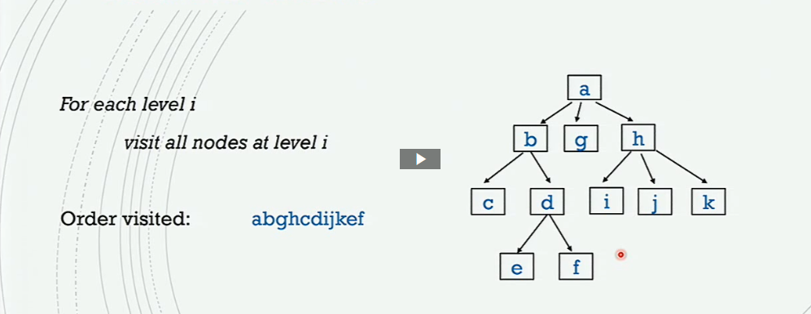
2. **Depth-first search (DFS) is:** starts at the root node (selecting some arbitrary node as the root node in the case of a graph) and explores as far as possible along each branch before backtracking.
3. **Breadth-first search:** starts at the tree root, and explores all of the neighbor nodes at the present depth prior to moving on to the nodes at the next depth level.
4. **Stacks implement:** depth-first
5. **Ques implement:** breadth-first
6. Geometric series formula to know at height h: 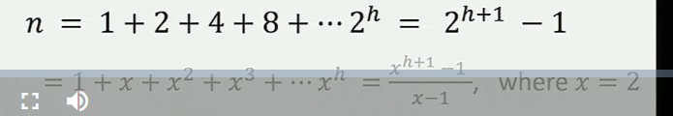
7. **In an expression tree, internal nodes**: are “operators”
8. **Leaves are:** “operands”
9. **Preorder traversal gives us a:** “pre-fix” expression
10. **Inorder traversal gives us a:** “in-fix” expression
11. **Postorder traversal gives us a:** “post-fix” expression
12. **Prefix expressions are called: “**Polish Notation”
13. **Postfix expressions are called:** “Reverse Polish Notation”
14. Postorder traversal on expression tree:   
    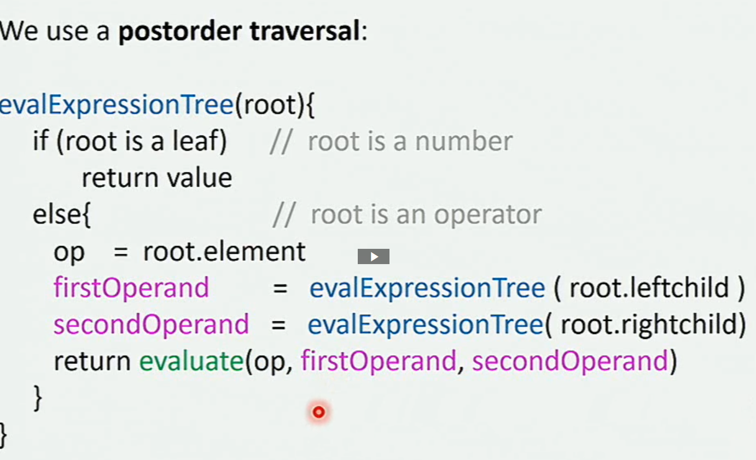

Evaluating postfix expression using stacks: 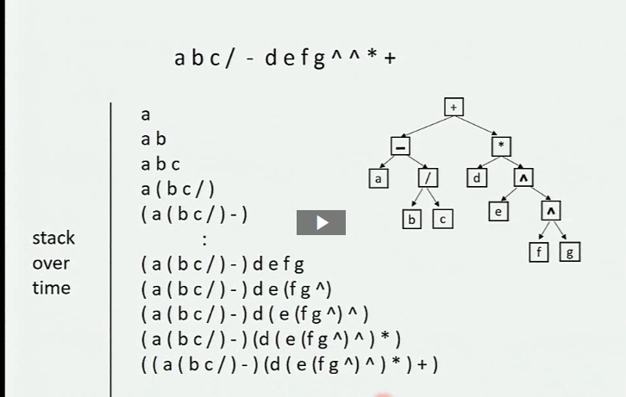

Algorithm:

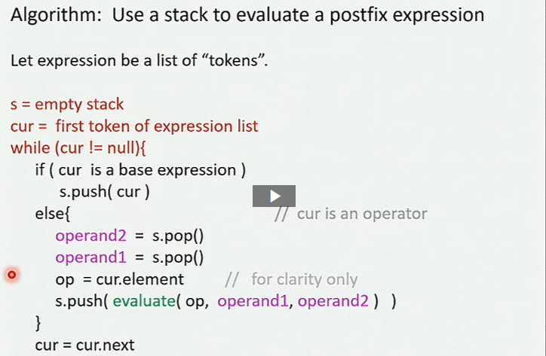

1. **Priority Queue:** like a queue, but remove next removes node with highest priority
2. 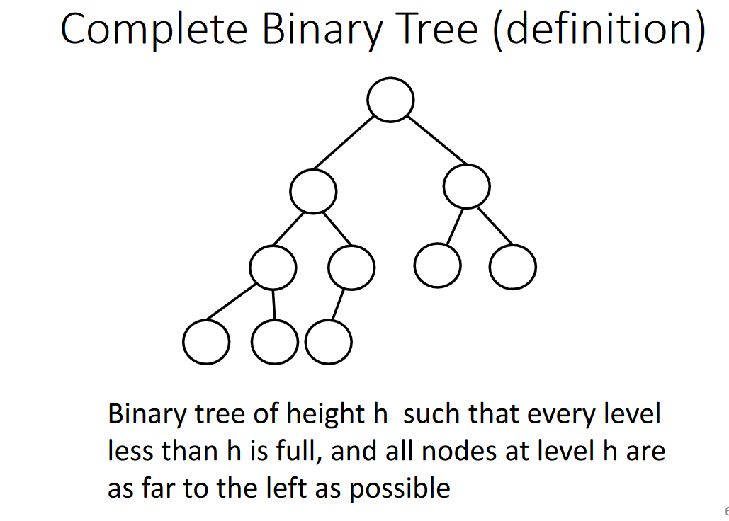
3. 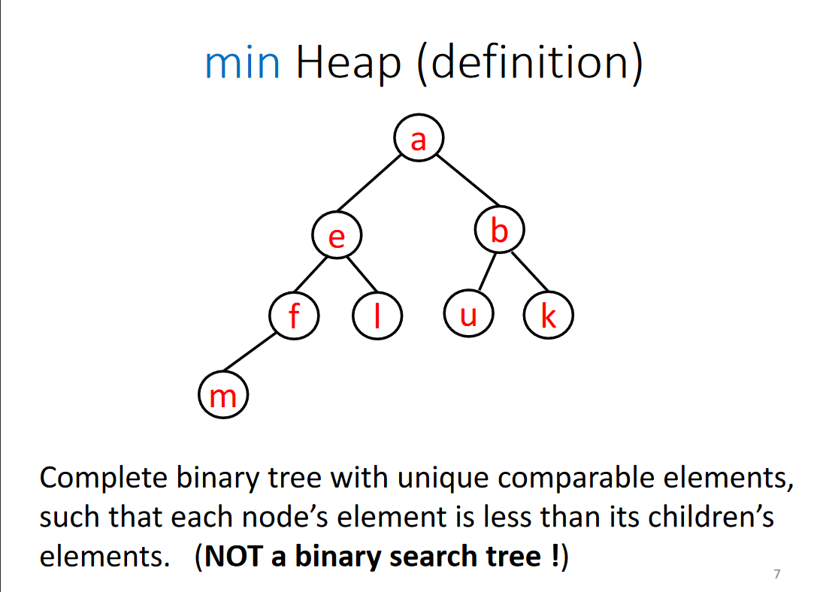
4. 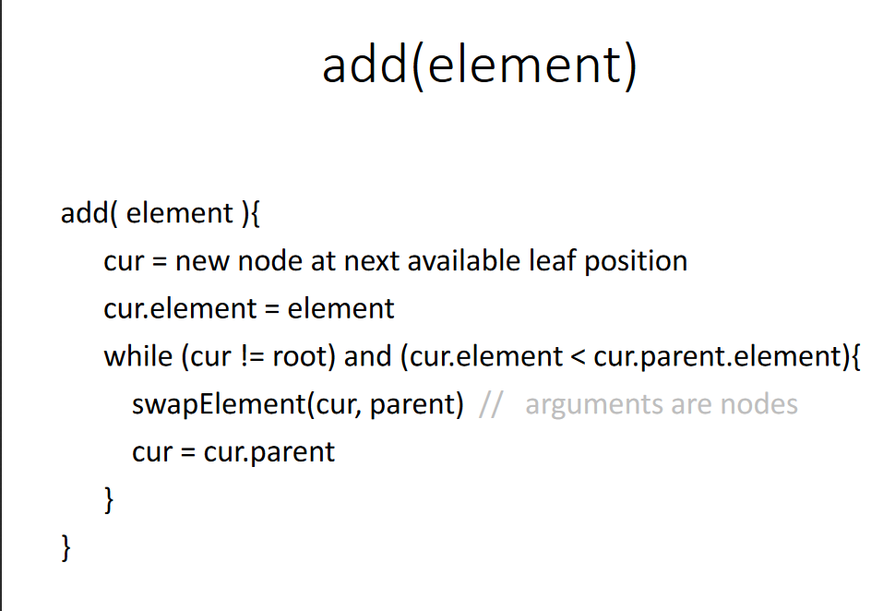
5. 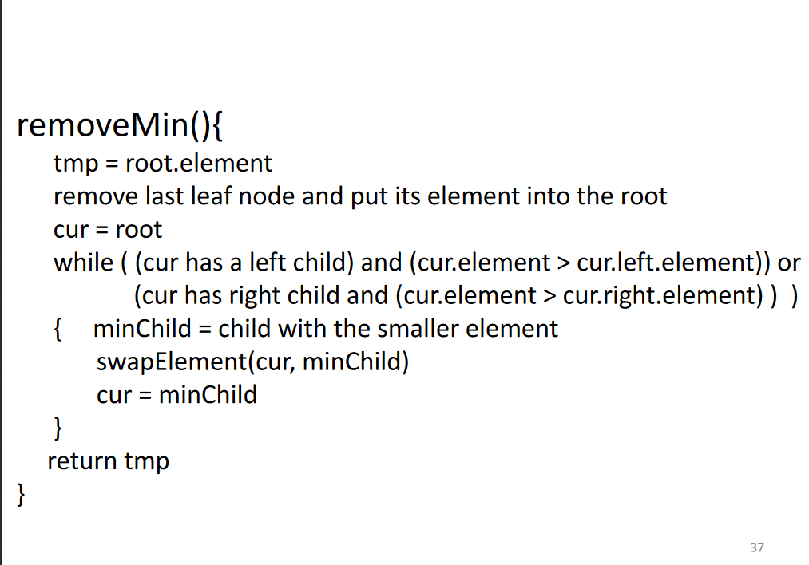

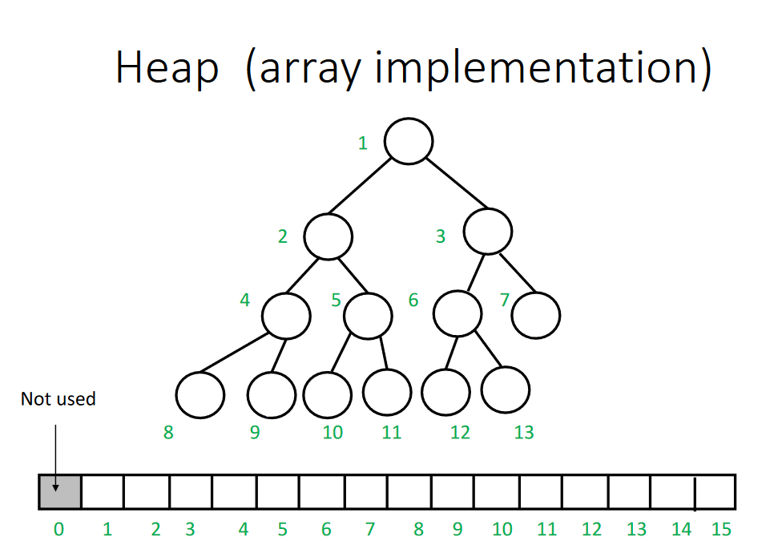

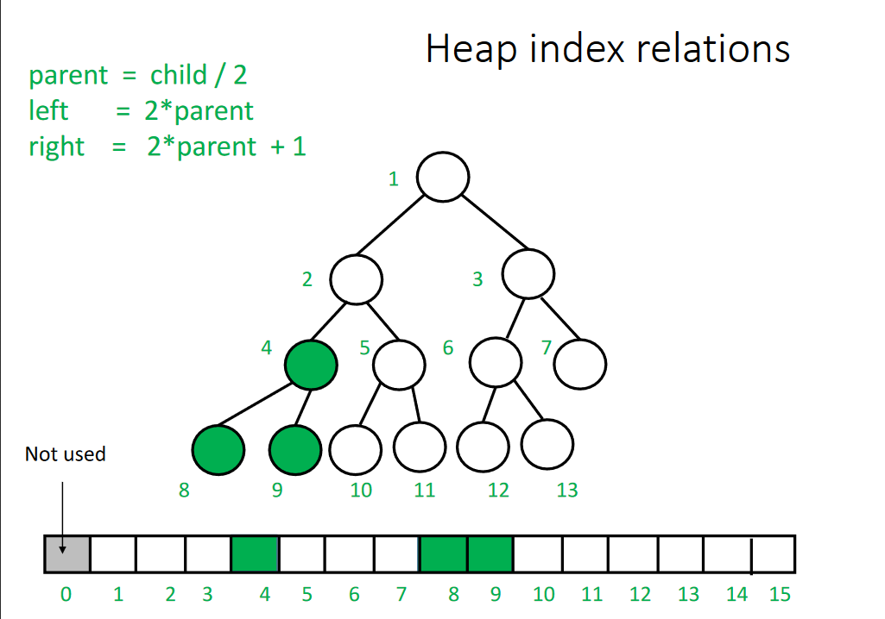

1. 